- 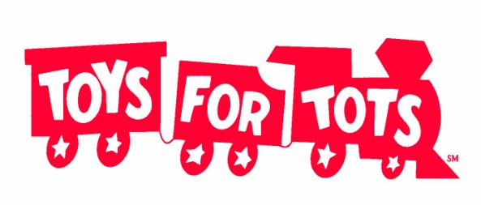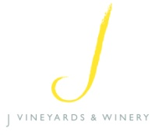
2012 Holiday Toy Drive

Alexander Valley Winegrowers
vs.
Russian River Valley Winegrowers

Nov. 26-Dec. 14, 2012

Jordan Winery (Alexander Valley) and J Winery (Russian River Valley) are hosting a friendly competition “wine country style” to see which wine region can fill grape gondolas with the most donations

Donations will be given to Toys for Tots for distribution
All donations must be received by 12 p.m. on December 14th
New, unwrapped toys and coats of any size are encouraged

Toy and coat drop-off instructions:
November 26-December 13, 9 a.m. to 4 p.m. Donations accepted on December 14 from 9 a.m. to 12 p.m. only.
ALEXANDER VALLEY: Jordan Vineyard & Winery, 1474 Alexander Valley Road, Healdsburg, CA 95448
RUSSIAN RIVER VALLEY: J Vineyards & Winery, 11447 Old Redwood Highway, Healdsburg, CA 95448
Donations can be placed in the Toys for Tots donation boxes located in each winery’s retail/tasting area. Jordan Vineyard & Winery will be closed on Sunday, December 2, Saturday, December 8, and Sunday, December 9.

Scale house weigh-in event will be held on Friday, December 14, at 2 p.m. at Jordan Vineyard & Winery’s crushpad.
Alexander Valley questions, please contact Lisa Mattson at Jordan: 707-431-5268 or lmattson@jordanwinery.com.
Russian River Valley questions, please contact Lindsey Auchter at J: 707-431-5482 or lindsey@jwine.com.
More details at http://blog.jordanwinery.com

